**KPI next to bar**

In order to use the last two years create the following two calculated fields.

Latest Year

**IF {MAX(YEAR([Order Date]))}=YEAR([Order Date]) THEN [Sales]**

**ELSE 0**

**END**

Duplicate the calculated field Rename it to **prior Year** and edit it as follows.

**IF {MAX(YEAR([Order Date]))}-1=YEAR([Order Date]) THEN [Sales]**

**ELSE 0**

**END**

**Open a new sheet**

**Drag the Sub-Category to the columns shelf and drag the Latest Year to the rows shelf and prior year to the details shelf.**

**Go to analytics tab and drag a reference line to the cell can create a reference line for every row based on the prior row.**

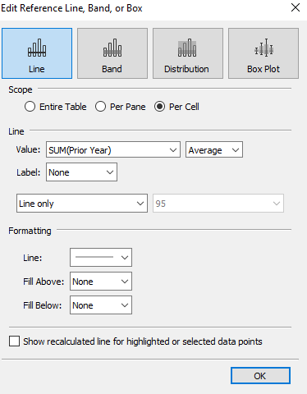

**Create a calculated field to show the difference between the two years.**

**YOY**

**SUM([Latest year])>=SUM([Prior Year])**

**Create another calculated field**

**Mark Position**

**avg(-1500)**

**Drag the Mark Position to the columns field and then dual axis and synchronize the axis.**

**Select the bar for the Sum(latest Year) on the columns shelf and shape for the Mark position.**

**Drag YOY to the shape and color on the marks card for the mark position and select the desired color and shape for the false and exclude the true.**

**To make the position of arrow dynamic every time we drag new dimension to the rows shelf duplicate the sheet and create a new calculated field.**

**Alert Position**

**-WINDOW_MAX(IF [YOY] THEN SUM([Latest year])**

**ELSE SUM([Prior Year])**

**END)*0.05**

**Replace the max Position in the columns shelf with the alert position.**